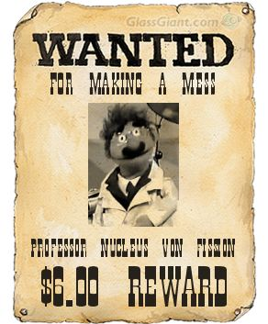
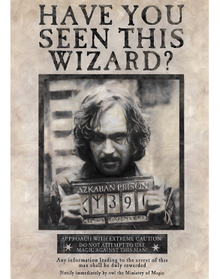

Wanted Poster

Directions: You and a partner will be assigned one of the following Outlaws of the Wild West. Research your outlaw and provide the following information on a “Wanted Poster”. Along with the following information, please provide an image of the outlaw. You may research and/or google examples of wanted posters. You may use templates found online or publisher.
Information Needed:
-Alias’ (known names)
-Wanted For: (Accused Crimes)
-Location/area of crimes or where the outlaw lived.
-Date (era/year’s alive)
-Description (physical description, age, traits, etc.)
-Other important information (accomplices, last seen, personal history, death information, interesting facts, etc.)
Outlaws:
-Billy the Kid
-Butch Cassidy
-Jesse James
-Joaquin Murrieta
-Apache Kid
-Belle Starr
-William “Buffalo Bill” Cody
-Wild Bill Hickok
-Wyatt Earp

Wanted Poster Rubric
 | History | 21st Century skills
Advanced (4) | Provides detailed information for all research areas specified in the Wanted Poster directions. | Wanted Poster has few or no errors and is completed in an exceptionally neat and organized manner, resembling a Wanted Poster from the Wild West.
Proficient (3) | Provides information for all but One of the research areas specified in the Wanted Poster directions. | Wanted Poster has few grammatical errors and is created in a neat and organized manner, resembling a Wanted Poster from the Wild West.
Basic (2) | Provides detailed information for all but Two of the research areas specified in the Wanted Poster directions. | Wanted Poster has many grammatical errors and is completed in an unorganized manner, not resembling a Wanted Poster from the Wild West.
Minimal (1) | Provides detailed information for all but Three or more of the research areas specified in the Wanted Poster directions. | Wanted Poster has too many grammatical errors and lacks qualities resembling a Wanted Poster from the Wild West.

