Creating a state task…

State of Mine
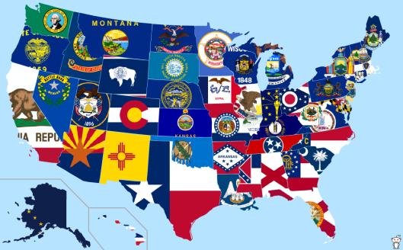
*Using publisher or poster board follow all the directions below to create a new state.

- I can create my own state from what I learned from readings and discussion from my group.
- I can make my own state from a new territory or from sections of present states.
- I can draw what the new state looks like with boundaries and borders.
- I can create my new state’s flag.
- I can create my state symbols.
- I can create my new state government and explain in detail from what I have learned about the Constitution.
- I can elect and name my two senators for my new elected state (research on famous people from my area, real people that would make great senators)
- I can label and list the cities in my new state including the capital.
- I can write about how my new state will be beneficial to the Union.
- I can summarize the process of how my territory will become a state in the Union.

