Religions in the Colonies
Presentation Assignment

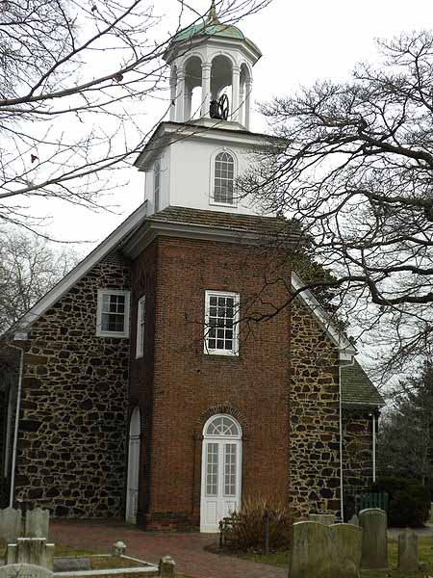

Direction: As a group research your assigned religion/denomination in the colonies. Create a powerpoint or Prezi presentation with no less than 10 slides on the information you researched. Please include pictures and the following: (for Baptist, Puritans, Quakers, Church of England, Roman Catholics, Lutherans, Jewish, Moravians, and Presbyterians)

-Intro to your researched religious group/denomination.
-Religion’s basic foundations: what makes it a religion/religious denomination or different from other religions?
-Locations of your researched religion/denomination in the colonies.
-Where did the religion begin and spread to?
-Who are the founder(s) of the demonization?
-How large was the denomination during colonial times compared to today?
-What are some conflicts your denomination have during colonial times?
-What kind of lifestyle did your followers of this denomination live?
-What impact did your denomination/religion have on the colonies or colonial life?
-Interesting facts on your denomination
-Researched sources

For those that were assigned The Great Awakening your presentation needs to have no less than 10 slides on the information you researched and include pictures and the following:

-Intro to the Great Awakening
-What was the Great Awakening during colonial America?
-Who was involved with the Great Awakening?
-How did the Great Awakening work?
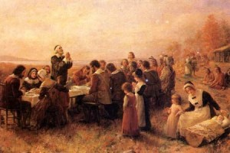
-How long did the Great Awakening last?
-How did the Great Awakening impact the colonies?
-Any conflicts that happened during this time?
-Interesting facts and numbers from the Great Awakening?
-In your opinion did it work?
-Could America have another Great Awakening in today’s society?
-Researched sources

For those that were assigned Calvinism your presentation needs to have no less than 10 slides on the information you researched and include pictures and the following:
-Intro to Calvinism
-Who was John Calvin and his beliefs?
-When did Calvinism start and who followed?
-What were some of Calvinism’s tenets or symbols (if any)?
-How big did Calvinism grow and what locations in the US?
-Does Calvinism still exist today (if so where and how many)?
-What impact did Calvinism have on Colonial America?
-What impact does it have on America today (if any)?
-Researched sources

For those that were assigned the Salem Witch trials your presentation needs to have no less than 10 slides on the information you researched and include pictures and the following:

-Intro to the Salem Witch Trials
-People involved with the Witch trials
-History behind this American event
-what two religions crossed paths with this event in Colonial America?
-describe the court hearings
-who was charged with being a witch and what happened to these people?
-where politics involved and if so how and why?
-was this just an American issue, if not where else did this take place?
-what impact did this do to Colonial America then and to America today?
-your thoughts and opinions on this event in history
-Researched sources
