From selling neckties in the Empire State Building to owning a $14billion company: Ralph Lauren receives Smithsonian honor for his patriotic designs featuring U.S. flag
- On Tuesday Mr Lauren was awarded with the James Smithson Bicentennial Medal
- The medal commemorates the 200th anniversary of the American flag that inspired the U.S. national anthem
- Hillary Clinton presented Mr Lauren with the award
By ASSOCIATED PRESS
PUBLISHED: 15:20 EST, 17 June 2014 | UPDATED: 09:00 EST, 18 June 2014

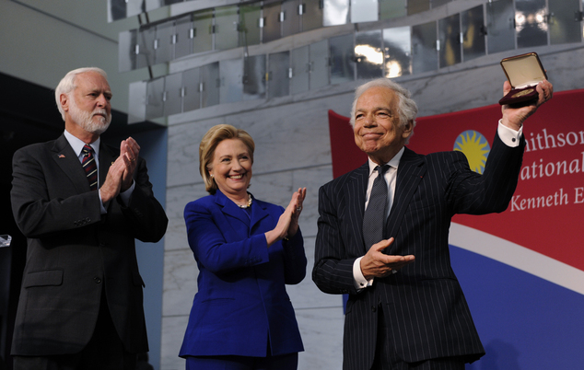
Ralph Lauren's love for the American flag and American style earned him high honors Tuesday from the Smithsonian Institution, celebrating his five decades in fashion.
Former Secretary of State Hillary Rodham Clinton helped present the James Smithson Bicentennial Medal to the 74-year-old designer at the National Museum of American History following a naturalization ceremony for 15 new U.S. citizens.
The award also marks the 200th anniversary of the actual flag that inspired the national anthem. Lauren helped fund a major effort to preserve that flag.
Taking an award: Designer Ralph Lauren (right), stands with Smithsonian Secretary G. Wayne Clough (left), and Hillary Clinton (center) has received the James Smithson Bicentennial Medal 'for his embodiment of the American experience through the medium of fashion, design and philanthropy'

Mrs Clinton noted that Mr Lauren is the son of immigrants from Belarus who grew up in the Bronx, New York.
'Now surely Ralph and his family ... could not have imagined, or maybe they could have when they landed in the Bronx, that their lives would be the embodiment of the American dream,' Mrs Clinton said. 'In particular, Ralph, the youngest, would become synonymous with American aspiration and style.'
Mr Lauren told the Associated Press that he cultivated this style as a young child, not out of an interest in fashion, but out of a yearning to fit in at school.
Because he was the youngest of four children, all of his clothes were hand-me-downs - many of which were old-fashioned or not his taste.
This inspired Mr Lauren to design and create his own clothes. He explained: 'When your parents are not able to afford the kind of clothes as a kid growing up, I had to work myself and earn my way and buy my own things. I just wanted to look like one of the guys and have the girls look at me.'
Mrs Clinton wore a pantsuit to Tuesday's event that was Mr Lauren's first-ever custom-designed outfit for her, which included a cobalt-blue structured silk jacket.
She toted a white Ralph Lauren Collection Soft Ricky Bag, which retails for $2,500.
'I think she looked fabulous,' Mr Lauren told U.S. News, adding: 'The color was spectacular, she loves color.'
Mr Lauren also wore an old suit - a pintstripe style that he continuously comes back to because he finds it comfortable and stylish.
He explained: 'I can say that I'm about style, not fashion. I'm about timeless style, about quality, and that doesn't mean it has to be boring. That means it's something that continues on because I don't throw out my clothes.
'The suit that I'm wearing is an old suit. I didn't just make this suit. I like the familiarity in a way because it's mine.'
Mrs Clinton and Mr Lauren first joined forces in 1998, when she was First Lady, to raise money for the Smithsonian to preserve the original 'Star-Spangled Banner' flag that inspired the national anthem, along with other historic artifacts, through her Save America's Treasures program.
Mr Lauren donated $10 million to help restore the flag and another $3 million to support the historic preservation program.
'Ralph responded to the call. He didn't have to,' Mrs Clinton said. 'But he understood because it was deep within him that part of being an American is giving back.'
The admiration is mutual. When asked by U.S. News if he would support a Clinton presidential bid, Mr Lauren said 'when she says yes, we’ll talk about it. I am a fan of Hillary’s.'
Mr Lauren is known for designs that have defined American fashion and for his patriotic uniforms for U.S. Olympic athletes.
He got his start selling ties from a drawer at the Empire State Building. Now Ralph Lauren Corp. has 25,000 employees worldwide.
But as Mr Lauren explained, his meager beginnings are the moments he is most proud of in his career.
'I started with neckties, which are a very small thing and people aren't even wearing them today. Neckties helped start my career. When a man wore a tie, it had to make a statement,' Mr Lauren said of his first entrepreneurial push, which is one of his favorite career moments.
The Smithsonian award citation honored Mr Lauren 'for his embodiment of the American experience through fashion, design and philanthropy.'
Sources: http://www.dailymail.co.uk/femail/article-2660183/Smithsonian-honors-Ralph-Lauren-fashion-flag.html

