Thursday, March 31st, 2011

Lost At Sea: 5 Stories of Disappearing Ships
Passing a boat exam not only ensures better safety for you and other boaters but prepares you for worst case scenarios but reduces the risks of getting into potentially harmful situations like getting lost. For as long as man has traveled the great big blue, stories of disappearing ships have inspired many a nautical lore. From Krakens to the Bermuda Triangle, with no living being or ship remains around to tell the real story, new theories for these odd disappearances emerge every generation. Yet despite an abundance of theories these ships' ends remain shrouded in mystery.
Here are 5 stories of unexplained ship and crew disappearances.

Mary Celeste: Year of disappearance: 1872
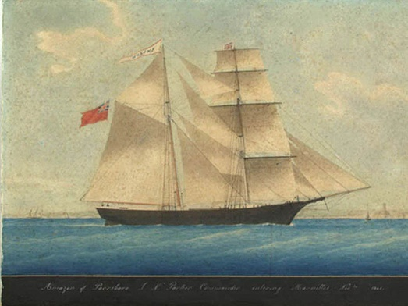
Mary Celeste is known as 'the greatest maritime mystery of all time' as she didn't disappear, but her crew and passengers did. She was a merchant 'ghost' ship spotted by a Canadian brigantine on December 4, 1872, unmanned, sailing off the Azores in seaworthy condition.
Her finders determined she had already been at sea for a month and had over six months' worth of food and water on board. The mysterious part was that her cargo was virtually untouched and the personal belongings of passengers and crew were still in place, including valuables.
There are many explanations that attempt to explain what happened. Some have suggested the crew aboard Mary Celeste could have been murdered and thrown overboard by Ottoman pirates, who frequently sailed the area. However, British officials dismissed any suggestion of piracy or foul play as there were no signs of violence. One of the most prevalent and plausible theories to date suggests that the crew perished after embarking on a lifeboat, fearing the ship's cargo may have been about to explode as they were transporting barrels of alcohol.

USS Cyclops: Year of disappearance: 1918
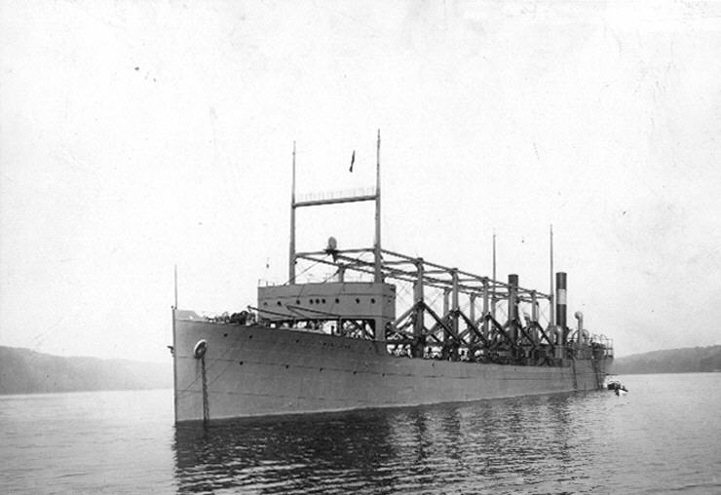
The Cyclops is perhaps the most famous of the early 20th century seafaring disappearances. She vanished sometime after March 4, 1918 with 309 men aboard. It remains the single largest loss of life in the U.S. Naval history which did not directly involve combat, though treason may have played its hand.
Investigations by the Office of Naval Intelligence revealed that the ship's master, Captain Worley was actually German-born Johan Frederick Wichmann. The most serious accusation against Worley was that he was pro-German in wartime and may have conspired with the enemy to hand the ship over to them.
After World War I German records were checked to establish the true fate of Cyclops, whether by Worley's hand or by a submarine attack, but nothing was ever found.

Marine Sulpher Queen :Year of disappearance: 1963
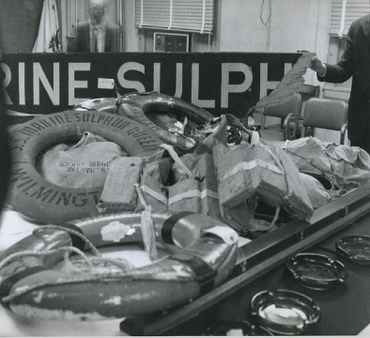
The remains of SS Marine Sulphur Queen, February, 1963 (USCG)
The SS Marine Sulphur Queen was originally a T2 tanker ship that was converted to carry molten sulphur. She disappeared off the cost of Florida taking with her the lives of 39 crew members. This would result in a lengthy litigation between the ship's owner and the families of the missing men.
The ship's last voyage began on 2 February 1963 out of Beaumont, Texas, with a cargo of sulphur weighing 15,260 tons. The ship itself weighed 7, 240 GRT. Two days later, as she reached Florida, she sent a regular radio message giving the position of the ship. As of February 6 there had been no news from the Sulphur Queen and she was declared missing. After 19 days of searching, all that was left was some life preservers and debris, but no trace of the ship or the 39 men.
In the Coast Guard's investigation they determined that the ship should never have sailed, as it was deemed unsafe and not seaworthy. The final report suggested 4 causes for the event. They were all due to the ship's poor design and maintenance.
Witchcraft : Year of disappearance: 1967
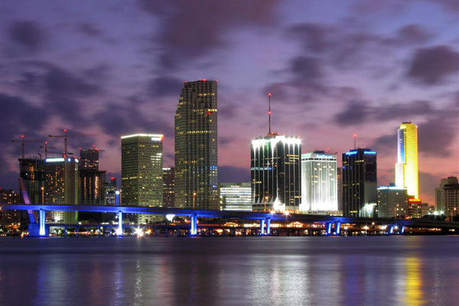
Dan Burack and Father Patrick Horgan left Miami's yacht marina in Burack's 23-foot cabin cruiser named Witchcraft on the night of December 22, 1967 to enjoy a spectacular view of Miami's Christmas lights. The two gentlemen stopped near Buoy #7 - less than one mile from shore when they hit something below. Calmly, Burack called the Coast Guard to inform them that he would need a tow back into the marina.
Burack had every reason to be calm. His ship was "unsinkable" meaning that part of the hull was built to remain above water plus, he had plenty of life saving gear aboard. The Coast Guard responded immediately, yet within 19 minutes of the call and their arrival on the scene, the ship and its passengers had vanished.
The Coast Guard expanded its search by 1,200 square miles that night. They even traveled northward to the Gulf Stream in case the ship had been pulled out by a brief squall.
Six days of searching, over 24,500 square miles covered, yet not even the slightest trace or clue as to the whereabouts of Witchcraft or the two men.
No explanation has ever has been given for Witchcraft's sudden disappearance. No evidence has ever indicated the ship even sank. All we can assume is that Witchcraft was lost so unexpectedly that Burack didn't even have the time to fire a flare gun he had onboard.

Intrepid: Year of disappearance: 1996
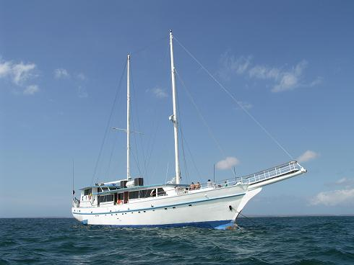
In October of 1996, 16 people went missing after reporting that they were abandoning their sinking yacht, Intrepid, off Fort Pierce, Florida. The passengers of the 65-foot yacht sent out a MAYDAY call saying the ship was sinking and everyone on board was escaping on a life raft. The Coast Guard reported that seas in the area were rough with waves up to 7 feet high. Four aircrafts searched all night and into the morning for the life raft. After searching 6,000 square miles, the search was called off. Intrepid and her 16 passengers were never found.

http://www.boaterexam.com/blog/2011/03/lost-at-sea.aspx

